[**info@istaoil.com**](mailto:info@istaoil.com) **· Tel: 021 88663901-3**

***Technical features for an ATEX gas heating system.***



|  |  |  |  |
| --- | --- | --- | --- |
| *Date:* | | | ***/ /*** |
| *Company:* |  | | |
| *Address:* |  | | |
| *Contact person:* |  | *Tel:* |  |
| *e-mail:* |  | | |

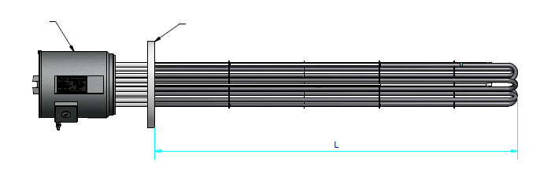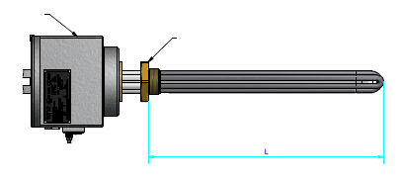

***IP65 HOUSING ALUMINUM***

***BRASS SCREW***

***IP65 BOX ALUMINUM***

***FLANGE***

|  |  |  |  |  |
| --- | --- | --- | --- | --- |
| *Liquid to heat:* |  | | | |
| *Accepted classified zone:* | II 2GD Ex d IIC T1…T6 Gb  Ex t IIIC T450…T85 C Db | | | T: * |
| *Power (in case it is known) (W):* |  | | | |
| *Voltage(V):* |  | *Single-phase* | *Three-phase* | |
| *Temperature of product (* *C):* |  | | | |
| *Work pressure design (bar):* |  | | | |
| *Maximum possible length “L”* |  | | | |
| * *It is compulsory to indicate* | | | | |

*NOTES:*

*• Heating systems are offered with 2 PT100 thermocouples (control+security). If another type of regulation is required it should be indicate it.*

*• If you have a drawing /picture of the equipment please send to info@istaoil.com.*

Resistencias Tope,S.A·C/Josep Ros i Ros 57·Sant Andreu de la Barca· Barcelona· SPAIN· Phone:+34 932 656 228

[**www.resistenciastope.com**](http://www.resistenciastope.com/) **·** [**admin@resistenciastope.com**](mailto:admin@resistenciastope.com)

Head Office: Apt 3, 4thFloor, No. 2, Vali Asr St., Tehran-IRAN· Phone: ‎021 88663901-3‎

**www.istaoil.com** **· info@istaoil.com**